Objective: To reinforce awareness of heat stress, its causes and symptoms, and steps for the prevention of heat-related illnesses

When the body is unable to cool off by sweating, heat-induced illnesses, such as heat rash, cramps, heat exhaustion, and heat stroke can occur. These illnesses can be serious, sometimes even resulting in death.
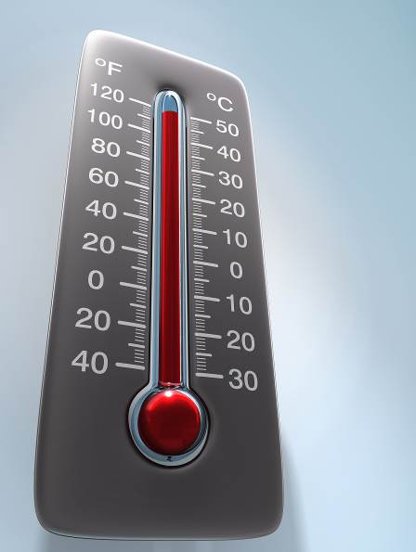
Factors Leading to Heat Stress

The following are common factors that can all contribute to heat stress:
- High temperature and humidity
- Direct sun or heat
- Limited air movement
- Physical exertion
- Poor physical condition
- Some medications
- A lack of tolerance for hot workplaces or areas
Heat Stress Prevention

- Know the signs and symptoms of heat-related illnesses, and monitor yourself and your co-workers.
- Block or avoid direct sunlight or other heat sources.
- Use cooling fans or air conditioning.
- Take regular breaks in shaded areas.
- Drink plenty of water or high-electrolyte fluids.
- Wear lightweight, light-colored, and loose-fitting clothing.
- Avoid alcohol, caffeinated drinks, and heavy meals.
- If you detect signs of heat exhaustion, notify a supervisor or appropriate individual with first aid training.

Heat Rash
- Symptoms: Cluster of small red pimples or blisters
- Causes: Excessive sweating, which leads to clogged pores and, if untreated, to infection
- First aid: Cleanse and dry the affected area, and use calamine lotion or powder to increase comfort.
Heat Cramps
- Symptoms: Painful spasms of leg, arm, or abdominal muscles, heavy sweating, and thirst
- Causes: Electrolyte deficiencies during or after strenuous physical activity, due to extended periods of intense sweating
- First aid: The affected individual must stop all activity, sit in a cool place, drink plenty of water or high-electrolyte fluids, and wait for a few hours after the cramps have subsided before engaging in any strenuous physical activities.
Heat Exhaustion
- Symptoms: Fatigue, profuse sweating, weak and rapid heartbeat, headaches, nausea, confusion, loss of coordination, muscle weakness, dizziness, or fainting
- Causes: Dehydration, lack of acclimatization to high temperatures, strain on the circulatory system, and reduced blood flow to the brain
- First aid: The affected individual must rest in a cool, shaded or air-conditioned area. First aid includes cooling the affected individual by fanning, misting with water, or applying ice packs. Give cool (not cold) water only if the individual is conscious.

Heat Stroke
- Symptoms: Core body temperature exceeding 104° F, hot skin with a lack of perspiration, strong and rapid pulse, nausea, confusion, dizziness, seizures or convulsions, or fainting
- Causes: Heat exhaustion was left untreated and the body’s cooling mechanisms have been exhausted
- First aid: Heat stroke is immediately life-threatening. Notify a supervisor and follow the emergency action procedure. While waiting for medical personnel to arrive, the individual giving care should take the following measures:
- Move the affected person to a cool, shaded or air-conditioned area.
- Give cool (not cold) water only if the individual is conscious.
- Cool the individual by fanning, misting with water, or applying ice packs.
- If necessary, loosen or remove heavy clothing.
Remember that most heat-related illnesses can be prevented by taking appropriate precautions.

This form documents that the training specified above was presented to the listed participants. By signing below, each participant acknowledges receiving this training.

Organization: Date:

Trainer: Trainer’s Signature:

Class Participants:

Name: Signature:

Name: Signature:

Name: Signature:

Name: Signature:

Name: Signature:

Name: Signature:

Name: Signature:

Name: Signature:

Name: Signature:

Name: Signature:

Name: Signature:

Name: Signature:

Name: Signature:

Name: Signature:

Name: Signature:

Name: Signature:

