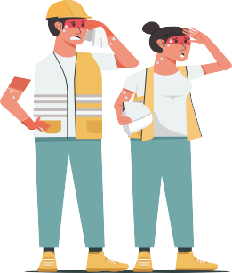
Stay Safe in the Heat
When temperatures rise, stay protected from dangerous heat exposures!

Prevention  Take care of yourself in hot weather and watch out for your co-workers. | 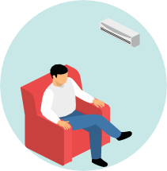  Hydrate Rest Shade  Eat Light Monitor Acclimate Meals Weather
Recognition  Know the early warning signs of heat illnesses to help prevent emergencies. | 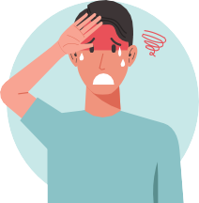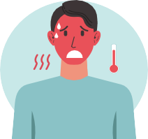  Cramps Headache Sweating  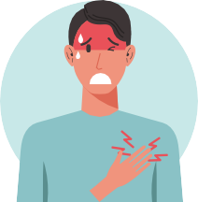  Rapid Pulse Red Skin Nausea
Response  Heat Stroke is a medical emergency.  Call 911 and notify your supervisor immediately. | 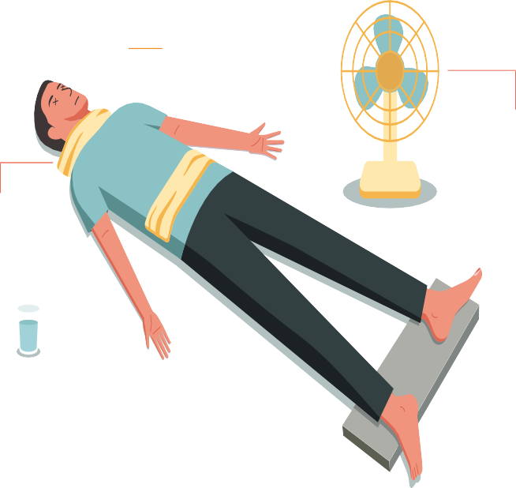  Heat Stroke First Aid - Call 911!  Remove Excess Clothing  Use cooling measures  Apply Cold Compress  Elevate  Provide Fluids Feet  (If they are able to drink)

